Only Order What You Need (OOWYN)

Communications toolkit

About the campaign

Around 1.4 million medicine items are wasted unnecessarily in Gloucestershire each year. This has an impact on patient safety, drug supply/chains, staff time and environmental pollution/carbon emissions.
The NHS in Gloucestershire is urging people not to stockpile medicines and “Only Order What You Need” to reduce waste.
​
How you can help spread the word​
​
- Download social media assets/digital screen images and via the extranet and share on your own social media channels/newsletters with the suggested copy.
- Some of the messages can be used with several of the assets, please feel free to use your own judgement.
- Please feel free to contact emma.simpson7@nhs.net or sophie.hopkins1@nhs.net if you identify any additional information which you feel would be useful to include in this toolkit and we will do our best to accommodate.

Social media​
​​
Twitter/Insta/Facebook/LinkedIn – suggested posts

COPY | ASSET
Did you know that around 1.4m medicine items are wasted unnecessarily in Gloucestershire each year? We need your help to reduce this. If you have a repeat prescription - only order what you need and don’t stockpile #OnlyOrderWhatYouNeed | Glos disposes motion graphic  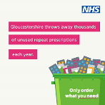  Photo animation C  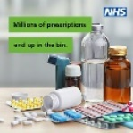
Unused medicines go out of date and might not work as they should. Only order the items you need and don’t stockpile #OnlyOrderWhatYouNeed | Campaign Overview GIF  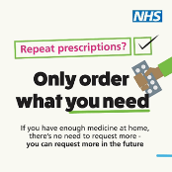  Key messages GIF  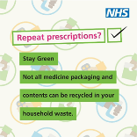
Stockpiling medicines worsens drug shortages. Please Only Order What You Need #OnlyOrderWhatYouNeed | Key messages motion graphic  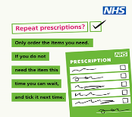  Photo Animation C
When you dispose of medicines properly, by handing them in to your pharmacy, you are helping to make sure that waste medicines do not pollute our rivers and seas #OnlyOrderWhatYouNeed | Safe disposal GIF  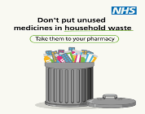
Medicines are only prescribed for you, and it is not safe to share prescribed medicines with anyone else #OnlyOrderWhatYouNeed | Photo animation B  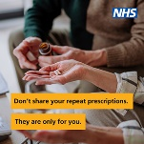
Stockpiles of medicines kept at home can be dangerous for children and pets #OnlyOrderWhatYouNeed | Photo Animation D or E  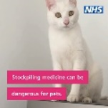  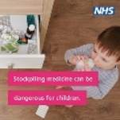
Only ordering what you need means that you are helping the environment as once medicines have left the pharmacy, they cannot be recycled or used by anyone else #OnlyOrderWhatYouNeed | Campaign overview motion graphic  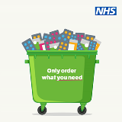
It’s quick and easy to order your repeat prescriptions using the NHS app. Download the app today #OrderWhatYouNeed | Key messages motion graphic  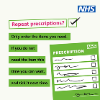
If you have enough medicine at home, there’s no need to order now – you can request more in future #OnlyOrderWhatYouNeed | Photo animation A  