One Gloucestershire ICS Inclusion Allies

November – December 2025

Programme Workbook

Workbook Owner: ________________________

Buddy Name: ________________________

Welcome to the Inclusion Allies programme.
This workbook contains activities for you to complete in between sessions to further your learning. This workbook is yours and for your reference only. You can use it as a word document and type in your thoughts, or you can print it out and scribble on it by hand, whatever works best for you.

Getting the best out of the programme
You will get the best experience out of this programme if you:
- Set aside a bit of time every week for the 5 weeks of the programme. Create quiet space where you can concentrate and do some personal reflection. You can use this time to:
  - Read through this workbook and complete the activities
  - Watch the recorded webinars (links below)
  - Make notes on your learning and reflections

- Meet with a buddy once a week to discuss the activities and reflect on your learning. You will receive an email introducing you to your buddy – someone on the programme and also works in one of the organisations in the Gloucestershire ICS

- Approach this programme, and your role as an Ally, with curiosity and openness. This is just the beginning of your learning journey: seek out more opportunities to learn.

Inclusion Allies programme outline
Week 1: Tuesday 18th November 2025, 10am: ‘Welcome to Inclusion Allies’ live webinar. This webinar will look at the why, how and what of the Allies programme. It will set you off on your learning journey to become an Ally and give you some ideas for the positive change you can make as an Ally.
Weeks 2, 3, 4 and 5: We have pre-recorded webinars for you to watch and reflect on, and some light reading and workbook activities. You will need to:
- Watch the ‘Inclusive Language’ recorded webinar and make notes
- Complete the privilege and bias activities in this workbook
- Watch the ‘Courageous conversations’ recorded webinar and make notes
- Arrange short meetups with your Buddy. This can be in person or via MS Teams. These are informal opportunities which give you a chance to get to know one another, and do some reflection on the learning you have undertaken.
Tuesday 16th December 2025 (2pm): ‘Graduation’ live webinar. This webinar is a space for you to reflect on what you’ve learnt so far and celebrate your graduation from the programme. Well done! Remember this is not the end of your learning, it is just the beginning.
Your Buddy
You will be introduced by email to the buddy that you have been assigned to.
We suggest you arrange your weekly buddy meetings as soon as possible. You can use your buddy to talk through the activities and webinars each week, reflect on what you’ve learnt and share in the journey together. This can be a short meeting or Teams call over a cuppa; remember to keep it informal, friendly and remain curious about one another and the contents of the programme.
We have prepared a proposed schedule for how you might approach the learning activities over the next 5 weeks.

PROPOSED SCHEDULE

Week 1 – Tuesday 18th November 2025
Your first session introduced you to the Allies programme and what being an Inclusion Ally means. We covered a lot in this first call, so we have included the slides as an appendix for you to refer to, when needed.
Buddy meetup week 1 – say hello, get to know one another a bit. Explore what you’re both looking forward to? What are your reflections on the content of the ‘Welcome to Inclusion Allies’ live webinar?

Week 2 – commencing Monday 24th November 2025
Plan time in your diary to:
- Watch the first recorded webinar ‘Inclusive language’ (length: 27 minutes):
Inclusion Allies - Session 2 - Self directed learning - YouTube
As you watch the webinar, make sure to pause it when instructed and reflect on the questions being asked. You can make notes at the end of this workbook if you wish. The link referenced in the video are is here: https://www.bbc.co.uk/news/uk-53194376

- Complete Section 1: Privilege (reading and activities) which is further down the workbook (page 4). Note that you can do Privilege activity 1 alone or with your Buddy.
Buddy meetup week 2 – discuss the privilege activities and inclusive language webinar
Week 3 – commencing Monday 1st December 2025
Plan time in your diary to:
- Complete Section 2: Bias (reading and activities) which is further down the workbook (page 7)
- Complete Section 3: Microaggressions (reading and activities) which is further down the workbook (page 8)
Buddy meetup week 3 – discuss the discuss bias & microaggressions activities

Week 4 – commencing Monday 8th December 2025
Plan time in your diary to:
- Watch the second recorded webinar ‘Courageous Conversations’ (length: 13 minutes):
Inclusion Allies - Session 3 - Self directed learning - YouTube
The Link referenced in the video is here: https://www.youtube.com/watch?v=OSsPfbup0ac

Buddy meetup week 4 – discuss the Courageous Conversations webinar

Week 5 – Commencing Monday 15th December 2025
Plan time in your diary to:
- Complete Section 4: Graduation Call and beyond which is further down the workbook (page 9)
Buddy meetup week 5 – reflect on the programme and next steps before you join the final webinar

Graduation webinar – Tuesday 16th December 2025

Section 1: Privilege
Privilege is linked to rank and power.
Rank is the position you have in relation to other people in society
Rank provides you with privilege & power
Aspects like gender, ethnicity, class, education, wealth and physical health are closely related to rank and can give us advantage over others.
You can’t control the amount of privilege you have, and you may also be unaware that you even have privilege
Principles:
- Privilege is power
- Power is privilege
- Power and privilege change when the context changes
Privilege activity 1
This activity is designed to be done either alone or preferably with your buddy on a Zoom/Teams call with cameras on. With a buddy face each other, put both your hands up, holding all fingers up (open palmed). One of you should read each of the statements below out loud. For every statement you agree with, put a finger down.
Put a finger down if:
▪ You can’t get married to your partner in your country of origin
▪ You can’t easily pass through security at the airport
▪ You can’t get credit easily (loans, mortgages, credit cards)
▪ You don’t speak, read and write English to a high level
▪ You can’t dress how you would like to, in public, without being harassed
▪ You can’t speak openly about your partner at work
▪ You didn’t go to university
▪ You aren’t employed
▪ Your home environment doesn’t allow you to work from home comfortably
▪ You have a disability, impairment or long term condition
▪ You aren’t white
▪ You aren’t cisgender (i.e. transgender or non binary)
▪ You are not heterosexual
▪ You have experienced mental health issues
(Generally, people with a higher number of ticks from this list will have less privilege. How many fingers do you still have up? Think about what this means, do you have significantly more up or down than your buddy? If there is a real discrepancy, talk about each other’s experiences about some of the above, if appropriate)

Privilege activity 2
Self-reflection (without buddy) How did it feel to go through the list? Did any emotions come up for you? E.g. discomfort, anger, surprise.
Spend some time thinking about the areas in which you do have privilege, and areas which you do not, and note them here:

Thinking points
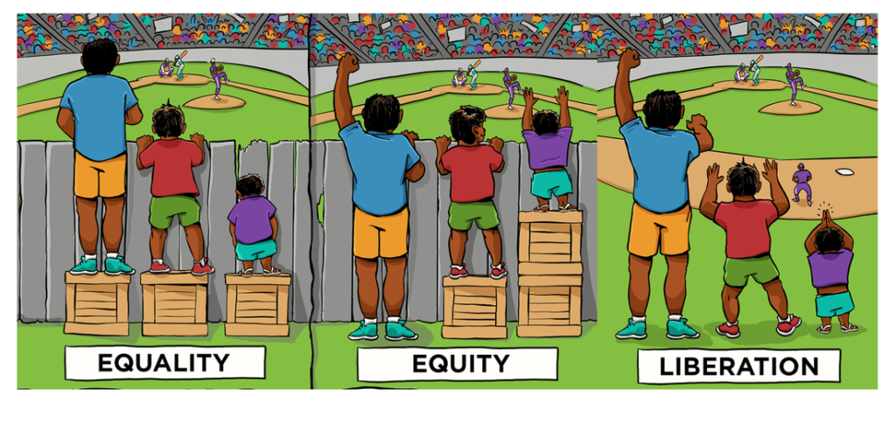
Source: The Centre for Story-Based Strategy
An example of the above process in action would be:
Diana is dyslexic. She is applying for a job at a new organisation and has been invited to interview, part of which involves a work-based test. She is the best candidate for the role, but because she did not finish the work-based test in time she is not offered the job.
In this instance, equality was setting every candidate the same test. Equity would have meant offering Diana additional time to complete the task.
Liberation (aka genuine inclusion) would have questioned whether checking spelling and grammar was a useful assessment at all for the role.
Think about the ‘equity – equality – liberation’ image above. How can you use your privilege to ‘add some boxes’ to the work you do so everyone can see over the fence or, (more preferably) remove the fence altogether?
How would you think about the three images above if you were describing a work meeting? What would be happening in the meetings in each image in relation to inclusion?
Because of the way privilege and power works, the voices and feelings of people with less privilege are often ignored or less valued. There will be situations where you can use your privilege to challenge discriminatory behaviour due to the way in which privilege works. For example, it may feel safer for a white person to challenge racial discrimination; or a heterosexual person to challenge homophobia; or a person in a client facing role to support their colleagues in business enablement teams. It is a delicate balance, but it can be worth thinking about when you can use your privilege to a) challenge people because they will listen to you and b) voice that you are not comfortable going along with the status quo, which can be particularly helpful in workplace ‘banter’ situations. Speaking up in this way can feel very supportive to the people on the receiving end of behaviours when done sensitively.
What commitment can you make as an ally to use your privilege to make a difference?
Section 2: Bias
Bias activity
Consider the following scenario:
A father and son were in a car accident where the father was killed. The ambulance brought the son to the hospital. He needed immediate surgery. In the operating room, a surgeon came in and looked at the little boy and said I can't operate on him he is my son.
Who is the surgeon?

This activity is designed to show how quickly our implicit biases form how we think and feel about situations with very little consideration for what lies outside of our initial thought. The surgeon is the boy’s mother (one study showed only 14% of respondents guess this right), or even could be another dad (if he had gay parents) but our brains are likely to sometimes trip up and think surgeons are male and therefore leave us confused in this scenario!
Now think a bit more broadly about unconscious bias: can you think of times when you did this at work? Or outside work? When are times you’ve been on the receiving end of bias, how has it made you feel? You’re welcome to make some notes/reflections in the box below.

Our implicit biases, that is, opinions, values judgements and stereotypes about certain people or groups that we may not be conscious that we hold, can show themselves in our behaviours. Our implicit biases can ‘leak’ from our unconscious mind into our body language, the words we use, and small comments we make every day. These are called microaggressions.

Section 3: Microaggressions
The term was coined by psychiatrist and Harvard University professor Chester M. Pierce in 1970 to describe insults and dismissals which he regularly witnessed non-Black Americans saying to Black people. By the early 21st century, use of the term had widened to include the casual degradation of any socially marginalized group, e.g. LGBTQ+ people, people living in poverty, and people that are disabled. More recently psychologist Derald Wing Sue has expanded the study of microaggressions, defining them as:
"The everyday slights, indignities, put downs and insults that people of color, women, LGBT populations or those who are marginalized experiences in their day-to-day interactions with people."
It is important to note that the ‘micro’ in microaggression does not mean inconsequential, it means they occur interpersonally rather than at an organisational (‘macro’) level. As Dr Sue points out, the impact of microaggressions is significant on people’s mental health and wellbeing.
Watch and read these links before moving onto the next task.
• You can find a video with Dr Sue here
• BBC article
Once you have read these articles and watched the videos, reflect on how you felt during them. Did any memories of times when you experienced microaggressions come up? Or did you recall times when you may have shown this behaviour towards someone else?

Reflect on what we’ve covered. What have you learnt? Are you surprised by anything?

It’s very likely that you’ve recognised times when your unconscious bias has shown itself in your behaviour, or via microaggressions. What actions are you going to take to change your behaviour and start challenging the biases you hold?
Section 4: Graduation call and beyond
We’ll have a graduation at the end of your programme, where you can share learning, actions and your own personal next steps
Before our final session reflect on and be ready to discuss the following. We have given you space to record your reflections:
What surprised you?
What did you enjoy?
What made you feel uncomfortable?
How can you and your buddy continue to support each other and hold each other accountable?
What support do you need from the other participants on the programme? What support can you offer them?
How will you share your learning with others in your team/those you work with?

